

|  |
| --- |
| alrajhi bank - Apps on Google Play  Project  Al Rajhi Bank App |

|  |  |
| --- | --- |
| N | Student Name |
| 1 | *Eiyad Al Dakheel* |
| 2 | *Mohammed Amer Alajmi* |

Supervised By: Dr.Mohammed Saad Mohammed Assiri

Year: 2023 – 1444H

Introduction:

AL Rajhi Bank It's helpful for personal banking services through your phone anywhere and anytime like transferring money from AL Rajhi Bank to any bank in the world fast as possible.

What problems will the application solve :

- a lot of problems like you can transfer your money to any bank

- you can check your money always and in an easy way

- the application will make you save more money or make you invest it in stocks.

Background :

We will talk about the AL Rajhi application which is one of the biggest banks in the world and was established in 1957, and he's known as the best Islamic bank.

purposed solution:

It will fix a lot of problems like you can transfer your money anytime, anywhere, and check how much money you have in seconds, you can Renew your bank card and create more than one bank account for one person.

Plan work:

The plan will be how we can make an application that is helpful for the client by doing probably everything he needs anytime, anywhere, and fast as possible as we can.

Functional Requirements

1. **Login**: Users can enter their own account by giving Username and password and then should enter a SMS verification code numbers for the first time then they can have more options for fast entering like (5-Digit Code , fingerprint).
2. **Create account**: Users can apply their new account in minutes and completely online all what they need complete personal information and system will check if it good to go or not with (Absher and SAMA) data.
3. **Balance**: Users should see their account money and transactions history.
4. **Transaction**: application should let users to withdrawals, transfers, and pay bill payments.
5. **Loan**: application may let users apply for loans, check monthly payments, and manage their account.
6. **Notifications**: application may send to users in SMS, E-mail, and in-app notifications for any actions you have made into your bank account.
7. **Search**: Users can type in a search bar for an easy and quick method.
8. **Support**: Users can contact support by phone, chat, and E-mail.

Non-Functional Requirements

1. **Performance**: system should be able to handle a large group of users and financial transactions at the same time without decreasing performance by slowdown time or crashes.
2. **Availability**: system must be working all the time, on all days.
3. **Usability**: system interface should be simple and easy to learn and adding hints message.
4. **Security**: system must provide auto logout when user is inactive, accept hard password only, temporarily block user that have too many failures password entered.
5. **Maintainable**: system should be designed to updateability and easy to find and solve bug fixes.

Activity diagram

Project Use Case Modelling:

Actors:

1. Customer.
2. Bank.

-diagram:

[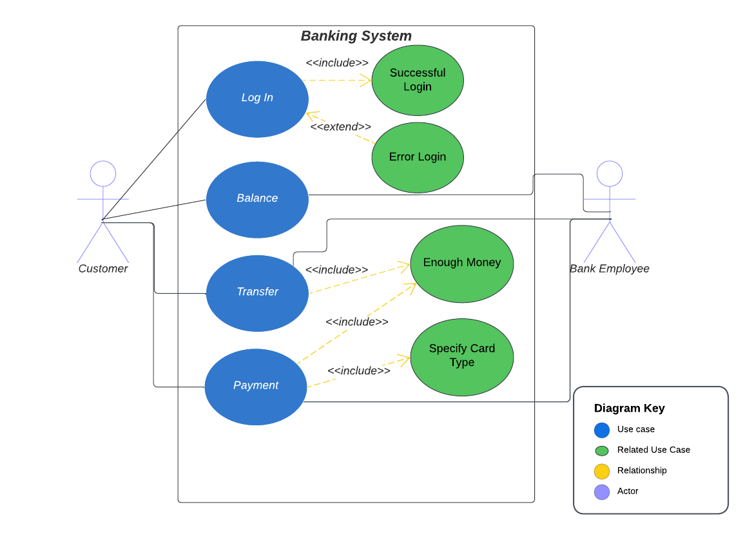](https://lucid.app/lucidchart/691d1f8c-7582-43ae-b2a7-f023a4d2e92a/edit?viewport_loc=203%2C70%2C2304%2C1134%2C0_0&invitationId=inv_40b578d3-996e-4206-b175-42055a65a795)

-Table 1: 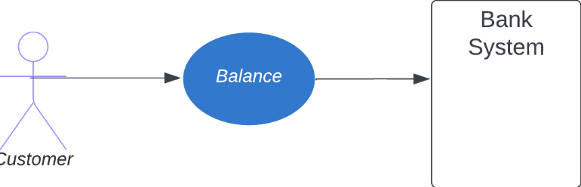

|  |  |
| --- | --- |
| **Customer-Bank: Balance** | |
| Actors | Customer, Bank Employee |
| Description | Customer wants to check their account balance. the bank is responsible for providing the customer with their account balance. |
| Data | Customer will find the Total Balance at the top home page and for more details, he should choose between accounts or cards that will show each balance. |
| Stimulus | Customer wants to check their balance to pay or transfer |
| Response | Balance has been seen |

-Table 2: 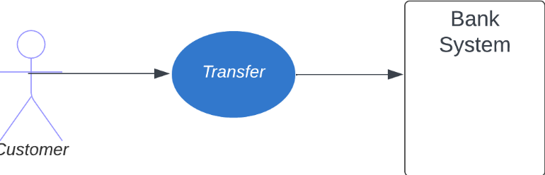

|  |  |
| --- | --- |
| **Customer-Bank: Transfer** | |
| Actors | Customer, Bank Employee |
| Description | Customers want to transfer money to their own accounts or other accounts to buy, pay, and gift to personal, company, and government |
| Data | Customer can choose between these features (One Time Transfer, My Accounts, Al-Rajhi, Local, International) then fill in Transfer Amount and Account at the end Confirmation |
| Stimulus | Customer apply the required information and confirm the transfer request. |
| Response | A confirmation message that transferred has been successfully |
| Comments | Customers should have the ability to know about transfers may be subject to fees, limits, and processing times and they can see the receipt and download it as (.pdf) or (.txt) file |

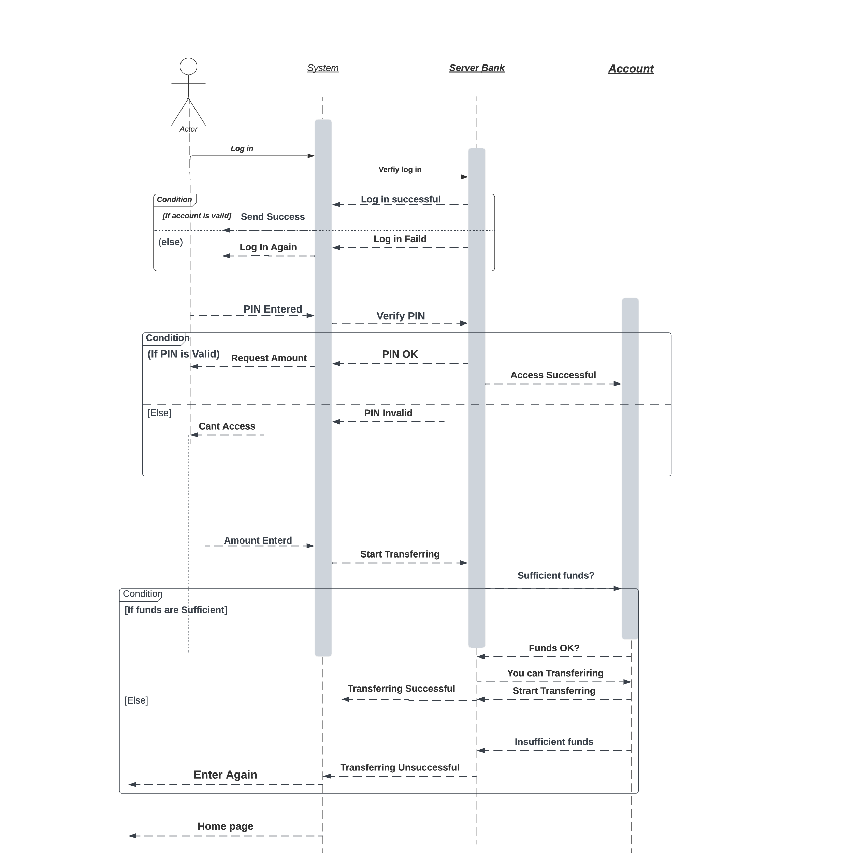Sequence Diagram:

Class Diagram: